1.Sign Up for a new account at MongoDB <https://www.mongodb.com/>

2.Click Build Cluster

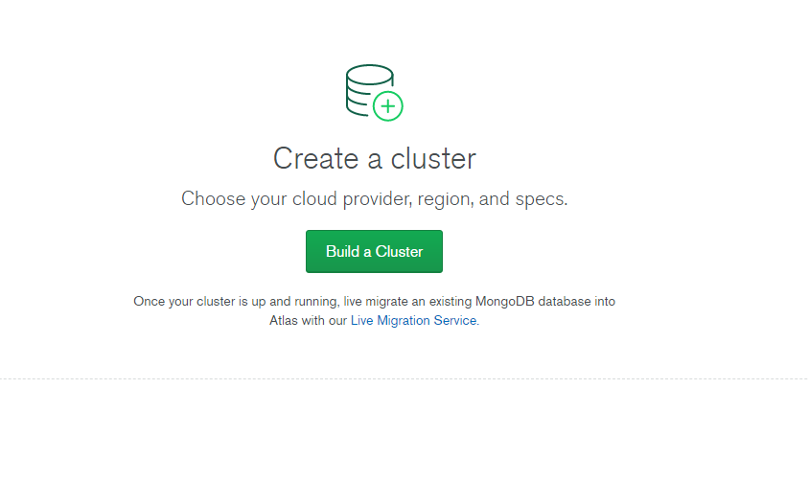

3.Choose the Cloud Provider and Region, select a region with ‘Free Tier Eligibility’

4. On the ‘Cluster Tier’ dropdown, select the Free Sandbox Environment

5. Once a cluster has been created, click on ‘Database Access’ under Security. Click on Add New User and fill in the username and password. Allow the user to read and write to any database

6. Click on the Network Access, on the IP Whitelist, click on allow access from anywhere, once that is done, click on the Clusters tab under Atlas and select Connect

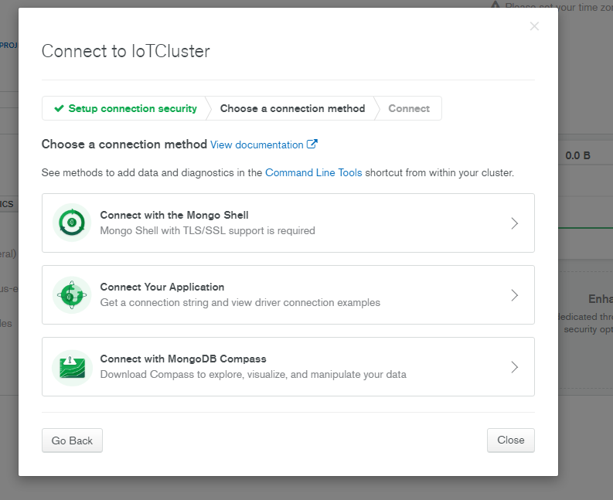

7. Choose connect your application

8. Copy the connection string and place it in your .env file, remember to change the password to use what you set earlier.